Module 4
Multiple Input / Output Linear Regression
M. 4 – Section 1
Multiple Output Linear Regression

📌 LR Multiple Outputs
This section focuses on implementing multiple-output linear regression using PyTorch. It explains how to handle input tensors, matrix-based predictions, and parameter shapes when models produce multiple outputs.

🔹 Multiple Output Linear Functions
Linear regression with multiple outputs extends the single-output linear model by computing multiple linear transformations in parallel:
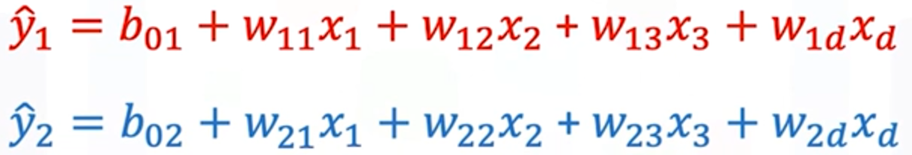
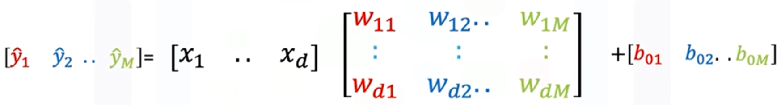
Each output corresponds to a separate linear function with its own parameters.
All the weights can be grouped into a matrix W, where:
- Each column in W represents the weights for a separate output.
- If there are D input features and M outputs:
- W is a D×M matrix.
- b is a 1×M bias vector.
- Input x is a 1×D vector.
The prediction ŷ is computed via:
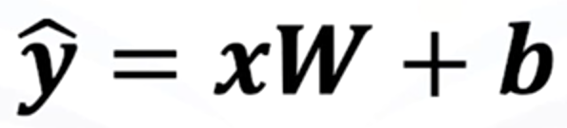
- The result ŷ is a 1×M vector — one output per linear function.
- The computation is visually broken down as:
  - Perform the dot product of the input vector x with each column of the matrix W.
  - Add the corresponding bias term.
  - Each result is a scalar output for a specific linear function.
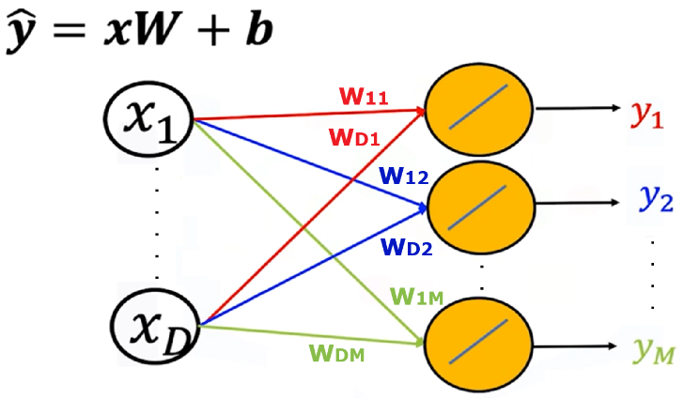
Directed graphs are used to represent:
- Input features as nodes.
- Weights and biases as edges.
- Multiple outputs as final nodes produced by distinct linear paths.
This structure generalizes cleanly to any number of outputs and features, enabling efficient multi-output regression.

🔹 Creating Custom Modules for Multi-Output Models
The custom module structure remains the same as before, but the parameter will be altered when the object model is created:
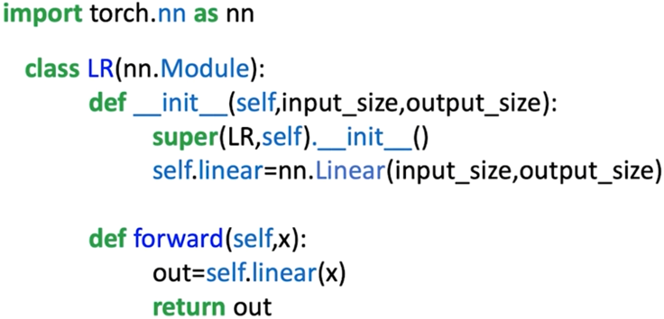
input_dim: number of features.
output_dim: number of outputs.
nn.Linear(input_dim, output_dim) is used to define the linear transformation layer.
The .forward() method handles the prediction call with self.linear(x).
The model behaves like nn.Linear, but allows full customization and extension when needed.
🔸 Predictions for a single input sample:
- Input: 1×D tensor
- Output: 1×M tensor
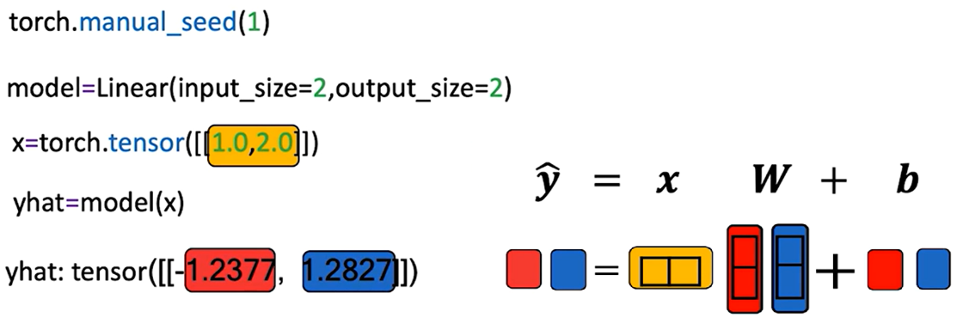

🔸Predictions for multiple sample:
- Input: N×D tensor (N samples with D features)
- Output: N×M tensor (N predictions with M outputs each)
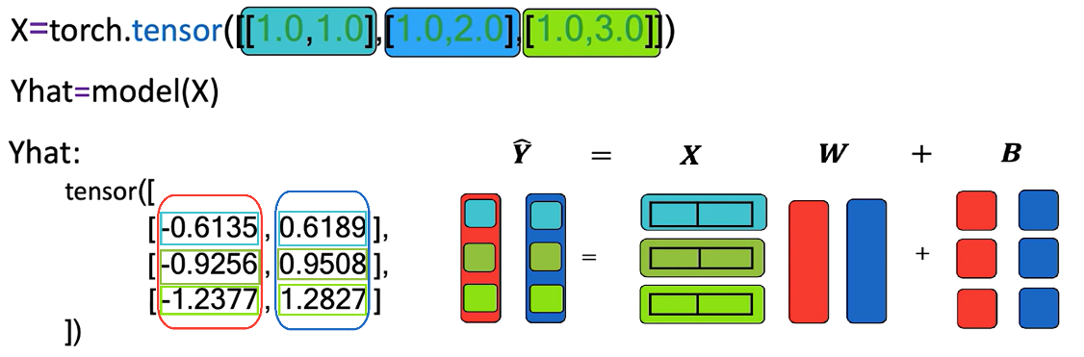
Each row in the output matrix Y corresponds to a sample.
- Each row of X is multiplied by W and then biases are added (broadcasted over all rows).
- The result is a matrix Y where:
  - Rows → input samples
  - Columns → output dimensions
The model uses dot product and broadcasting to generate predictions across all outputs and samples efficiently.

✅ Takeaways
✅ Multiple-output linear regression models produce M parallel predictions using a single matrix of weights and a bias vector.
✅ PyTorch’s nn.Linear and custom modules can easily accommodate multiple outputs by setting out_features > 1.
✅ Matrix operations (dot products and broadcasting) are essential to compute predictions efficiently across samples and output dimensions.
✅ Custom modules maintain flexibility while maintaining compatibility with PyTorch's model API.
✅ The output of the linear transformation is a 2D tensor, where rows represent samples and columns represent outputs.

📌 Multiple Output Linear Regression Training
This section explains how to train a multiple-output linear regression model in PyTorch.

🔹 Cost Function for Multiple Outputs
When the model has multiple outputs, both the target values y and the predictions ŷ are vectors.
- The cost function is the sum of squared distances between the prediction vector and the target vector across all outputs:
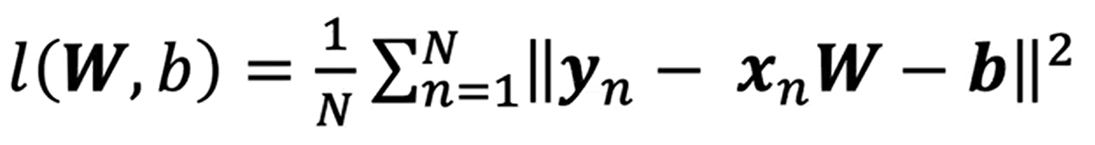
This formulation accounts for all output dimensions simultaneously.
The weight parameter W is a matrix (one column per output), and the bias term b is a vector (one element per output).
The gradient descent update equations remain the same in principle, but the operations are vectorized to handle multiple outputs in parallel.
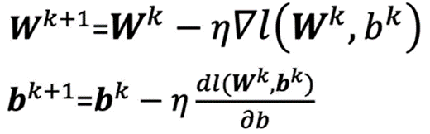

🔹 LR Training in PyTorch
🔸Model structure:
The custom module or class for the model remains unchanged from the single-output case.
The key difference is in the parameters passed when creating the model:
  - in_features → number of input features.
  - out_features → number of outputs.
This ensures the model’s weight matrix W and bias vector b are sized appropriately for multi-output predictions.
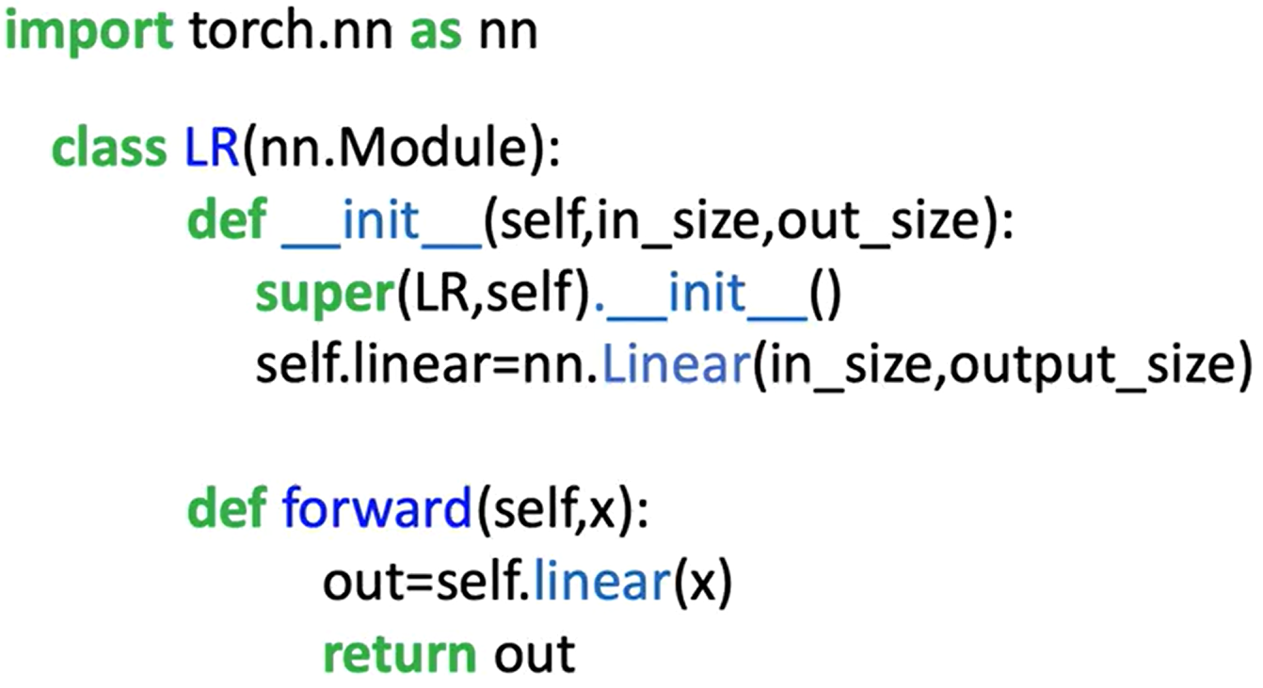
🔸 Dataset and DataLoader:
The dataset class is adapted to generate two target values per sample instead of one.
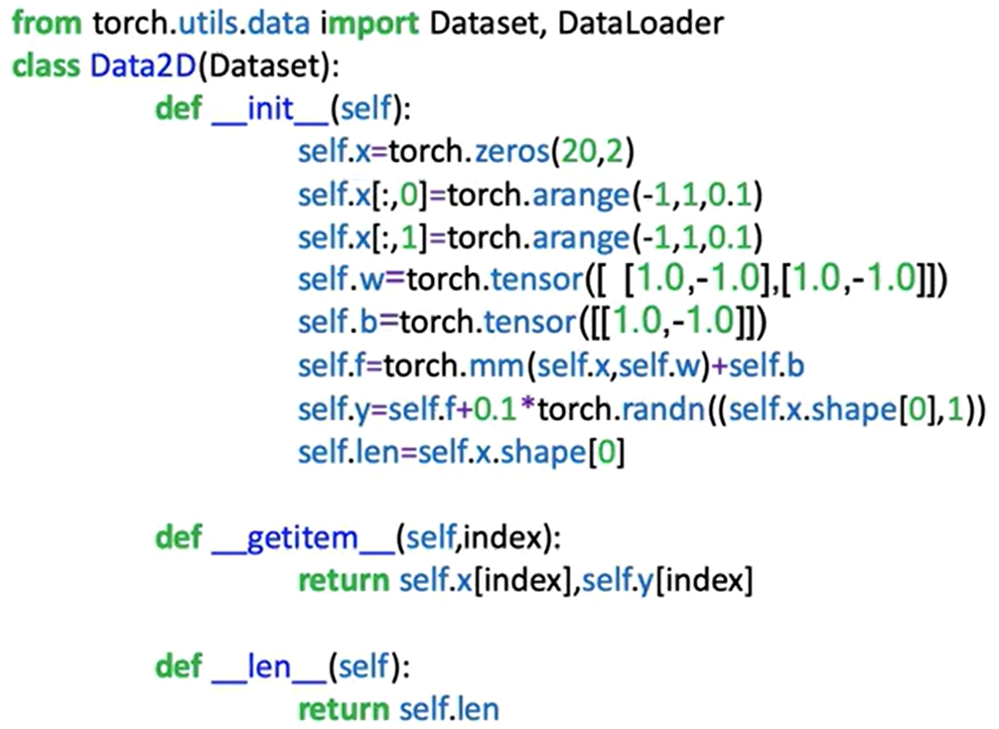
A dataset object is instantiated with both the feature matrix X and the multi-output target matrix Y.
🔸 Training Loop:
The training procedure follows the standard PyTorch workflow:
- Initialize:
- Create the model object with two input features and two output features.
- Define the cost function (criterion).
- Create the optimizer (e.g., SGD) with a specified learning rate.
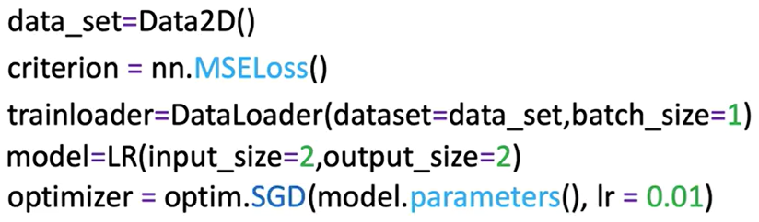

- Iterate over epochs:
For each epoch:
- Loop over the DataLoader batches.
- Forward pass: Input batch → model → predictions (ŷ).
- Compute loss: Compare ŷ with target y using the cost function.
- Zero gradients: optimizer.zero_grad() to reset gradient accumulation.
- Backward pass: loss.backward() to compute gradients of all parameters.
- Update parameters: optimizer.step() to adjust weights and biases.
The update step applies matrix operations that adjust all weights and biases for all outputs in one step.
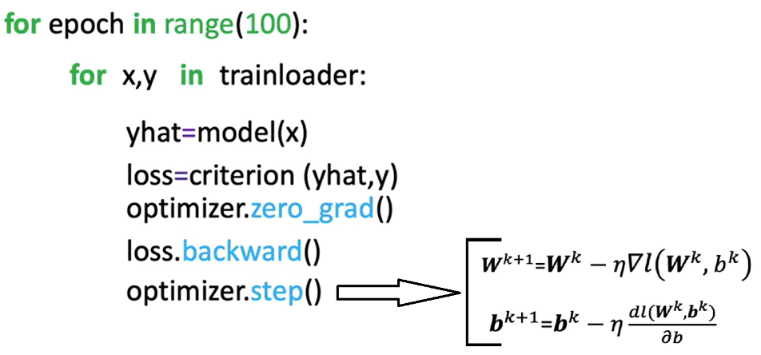

✅ Takeaways
✅ In multi-output regression, the target y and predictions ŷ are vectors, requiring the cost function to sum squared differences across all outputs.
✅ The weight parameter W becomes a matrix, and the bias b becomes a vector when moving from single to multiple outputs.
✅ The PyTorch training loop for multiple outputs is essentially identical to the single-output case, with changes only in tensor shapes and dimensions.
✅ Vectorized updates allow all output parameters to be optimized simultaneously in each training step.
✅ The same custom model architecture can be reused for single or multiple outputs by adjusting the out_features parameter when instantiating the model.

M. 4 – Section 2
Multiple Linear Regression Prediction

📌 Multiple LR Prediction
This section introduces how to implement multiple linear regression using PyTorch for multiple input dimensions.
The focus is on building models using both nn.Linear and custom modules through nn.Module, while exploring shape consistency, vectorized operations, and how PyTorch handles parameter initialization and predictions for multiple samples.

🔹 Multiple Linear Regression in Multiple Dimensions
In multiple linear regression, the model predicts an output using multiple input features.
A single prediction is obtained using a linear combination of input features:
$$\hat{y}=x_{1}w_{1}+x_{2}w_{2}+…+x_{D}w_{D}+b$$
where:
- x is a 1 × D tensor (feature vector).
- w is a D × 1 tensor (weight vector).
- b is the bias (scalar).
- ŷ is the predicted value or dependent variable.
The shape consistency is key:
- Columns of X must match the number of weights.
- The same bias term b is added to each dot product.
For a matrix X with multiple rows (samples), each row is passed through the dot product with the parameter vector w, and the same bias b is added.
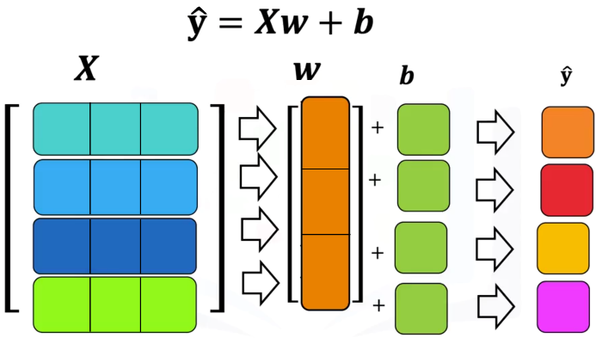
The process is repeated for each sample:
- First row ⋅ weights + bias → first prediction.
- Second row ⋅ weights + bias → second prediction.
- And so on.
The output is a vector of predictions (one per sample).

🔹 Linear Regression using nn.Linear
PyTorch’s built-in nn.Linear is used to define linear transformations.
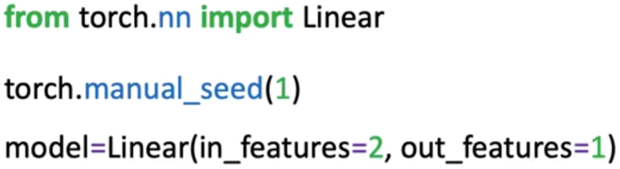
- in_features correspond to the number of input columns (features).
- out_features correspond to the number of outputs (usually 1 for regression).
Internally, nn.Linear:
- Initializes weights and bias randomly.
- Stores parameters accessible via .parameters() (list() function must be applied to get an output as the method is lazily evaluated) or .state_dict().
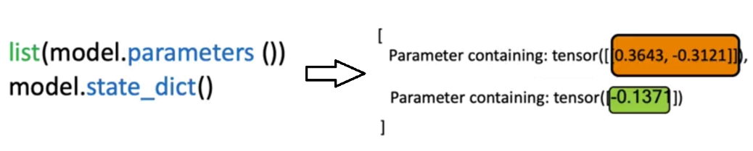
Single-sample and batch predictions:
- A 1×D input returns a 1×1 output.
- An N×D input matrix returns an N×1 output (one prediction per sample).
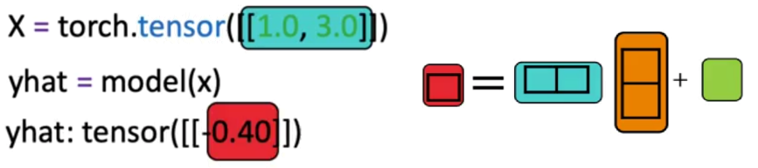
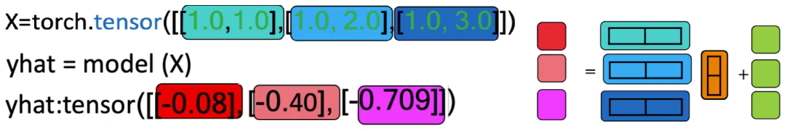

🔹 Custom Modules
For extensibility, PyTorch allows defining custom models using nn.Module.
The custom class inherits from nn.Module and defines:
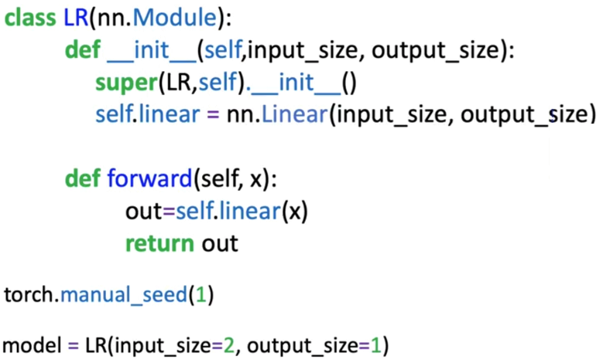
- A constructor where the internal nn.Linear is created. super().__init()__ ensures nn.Module methods and attributes are inherited.
- A forward method to compute predictions.
Once defined, the object behaves like nn.Linear:
- It can be called on a tensor directly (e.g., model(x)).
- It supports both single-sample and batch inputs.
This setup will be crucial when constructing more complex neural networks.

✅ Takeaways
✅ Multiple linear regression generalizes to D-dimensional inputs using dot products and bias addition.
✅ Shape alignment is required: input features must match parameter dimensions.
✅ nn.Linear handles linear transformations efficiently and supports parameter access via .parameters() and .state_dict().
✅ Batch input handling returns a prediction per sample via matrix operations.
✅ Custom models built using nn.Module are essential for flexibility and will be used throughout neural network design.

📌 Multiple LR Training with PyTorch
This section focuses on implementing the training procedure for multiple linear regression using PyTorch.
It introduces the full pipeline to train a model on 2D input data using PyTorch's nn.Linear class, DataLoader, and autograd functionality.

🔹 Cost Function and Gradient Descent in Multiple Dimensions
In multiple linear regression, the cost function measures the discrepancy between predicted values ŷ and true targets y. The cost is computed using the squared error:
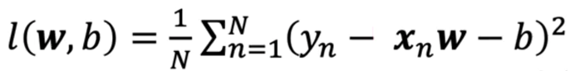
Here, ŷ (x_{n x} w – b) is computed as a dot product between the input feature vector x and weight vector w, plus a bias term b.
For an input of d dimensions:
- d d weights + 1 bias = d + 1 parameters.
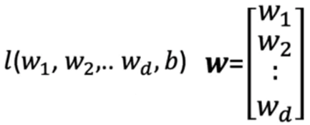
The gradient of the loss with respect to:
- Bias (b) is a scalar.
- Weights (w) is a vector of partial derivatives.
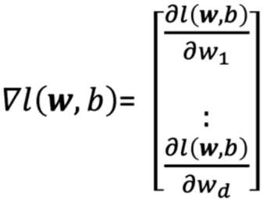
Weights update rules in vector form:
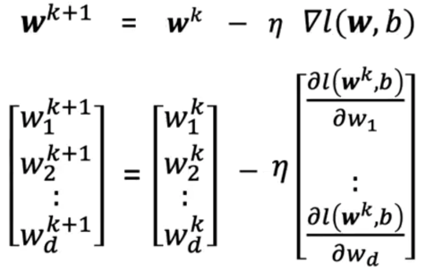
- η is the learning rate.

🔹 Training the Model with PyTorch
The training procedure follows the same structure as single-variable regression, in this example 2D input tensors will be handled.
Steps:
  - Create utility classes:
- Create linear custom model that inherits from nn.Module and behaves like nn.Linear.
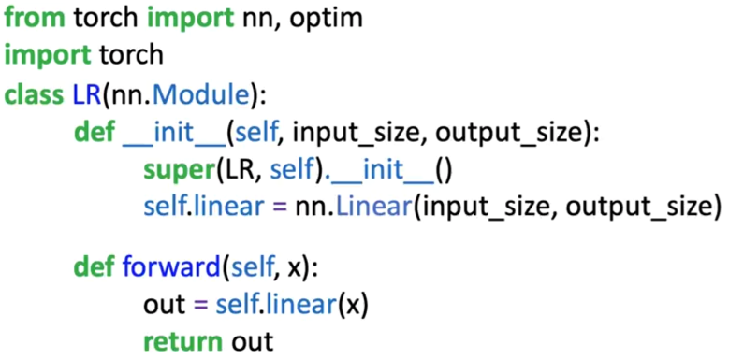
- Define a dataset class to create the dataset object. It has two dimensions for the input x.
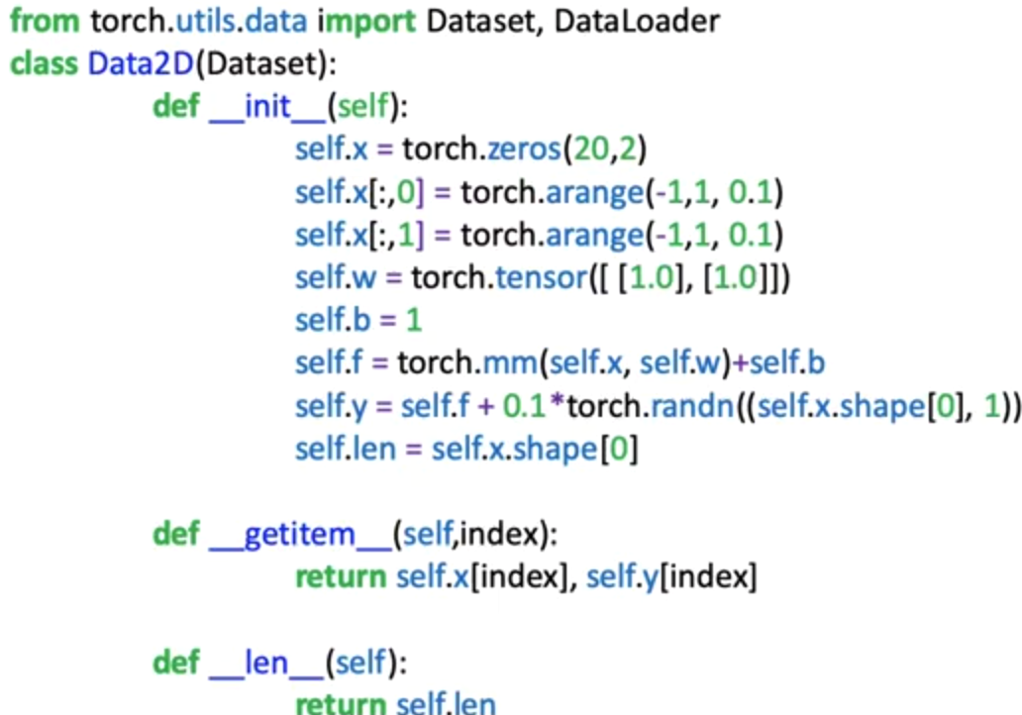
  - Define training parameters:
- Use the pre-defined class to create a dataset.
- Define the loss function or criterion.
- Create DataLoader object for mini-batch training.
- Instantiate the custom model.
- Define the optimizer.
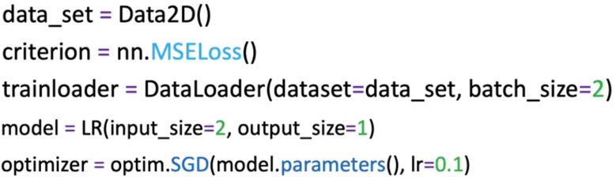
  - Loop through every epoch to update parameters:
- For each epoch:
- Loop through each mini-batch of samples.
- Perform a forward pass: compute predictions.
- Compute the loss between predictions and ground-truth labels.
- Set gradients to zero using optimizer.zero_grad() to prevent accumulation.
- Perform backward pass: compute gradients using loss.backward().
- Update model parameters with optimizer.step().
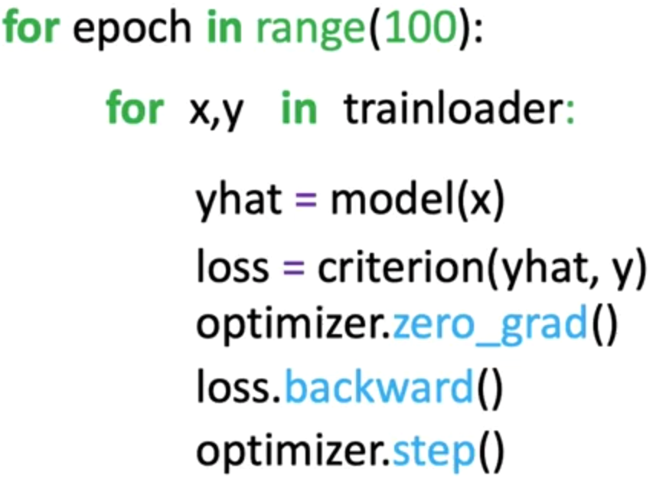
- This process performs a vectorized update to all weights and bias simultaneously based on the computed gradients.
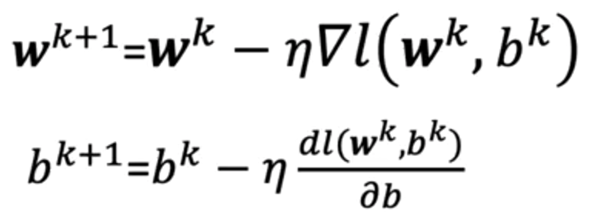

✅ Takeaways
✅ In multiple linear regression, each feature has a corresponding weight, and the model includes a bias term.
✅ The cost function generalizes to higher dimensions by summing squared errors across all feature combinations.
✅ Training with PyTorch involves:
- Defining a model using nn.Linear,
- Creating a DataLoader for batch processing,
- Using optimizer.step() and loss.backward() for gradient-based updates.
✅ After enough epochs, the model improves its ability to track the training data using the learned parameters.

